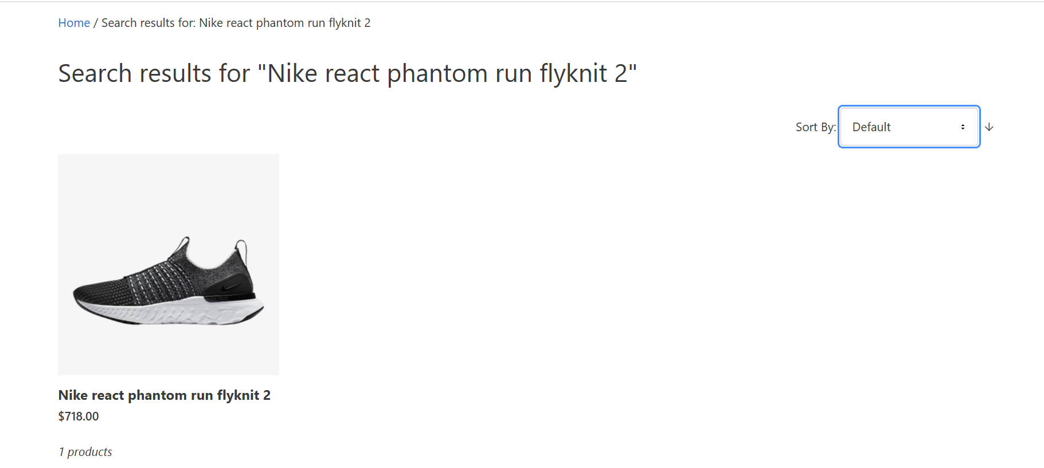

Test ID 8 : Search result page is not showing any trending products